EXERCISE-30

30.Design NFA to accept any number of a’s where input={a,b}.

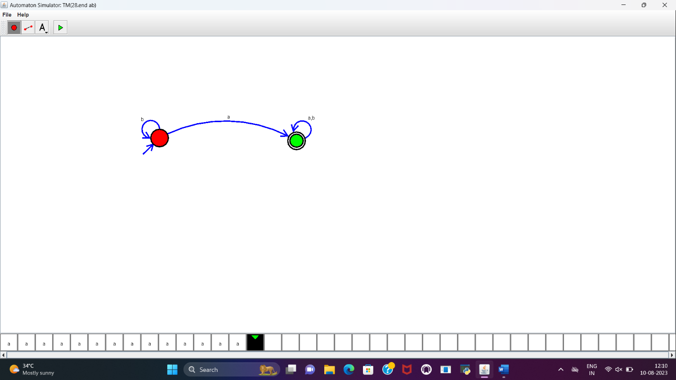

RESULT:

NFA to accept any number of a’s is designed and implemented successfully using simulator.